**DCRN Wallet Windows Installation and Stake Tutorial**

Step 1: Open the website: <https://dcrn.xyz/wallet>

Step 2: Click **Windows** and then click **Install Wallet for Windows** to download the DCRN wallet for Windows

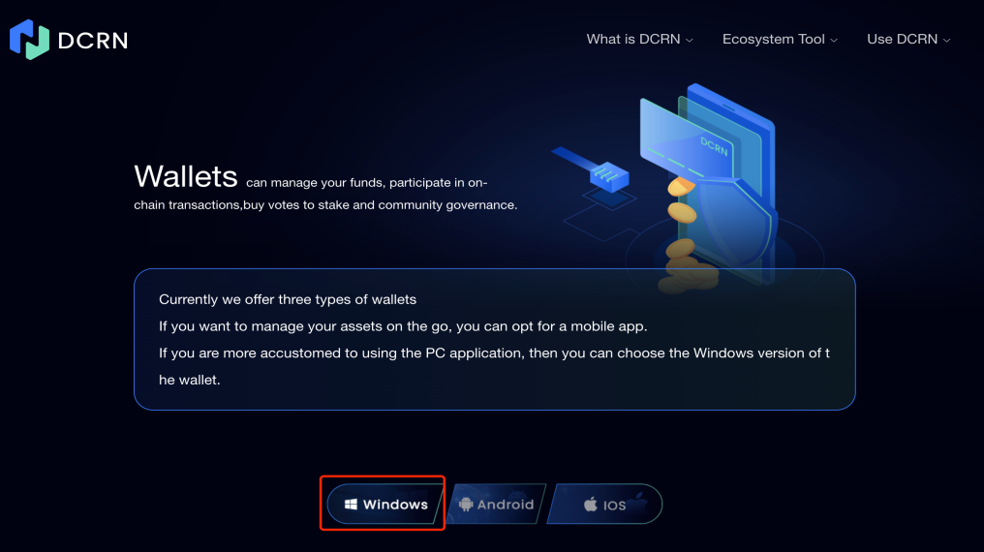

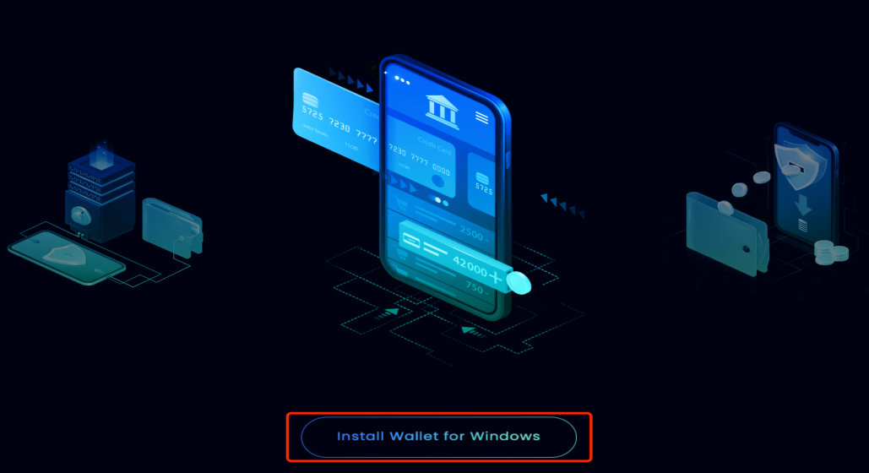

Step 3: Open the DCRN Wallet and click **Create a New Wallet.**

If you already have a DCRN Wallet, you can click **Restore Existing Wallet.**

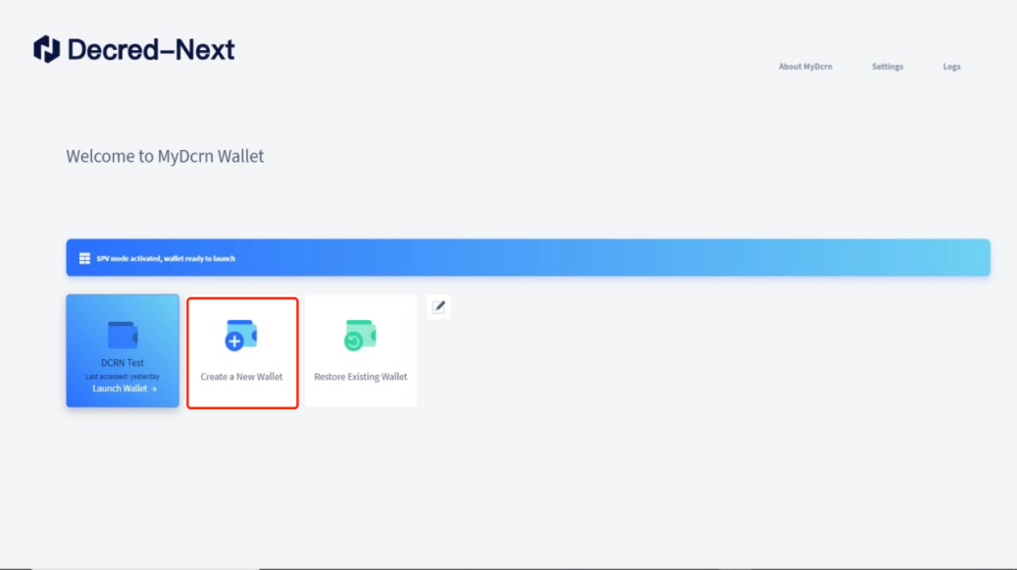

Step 4: Enter the Wallet Name by yourself and click **Continue.**

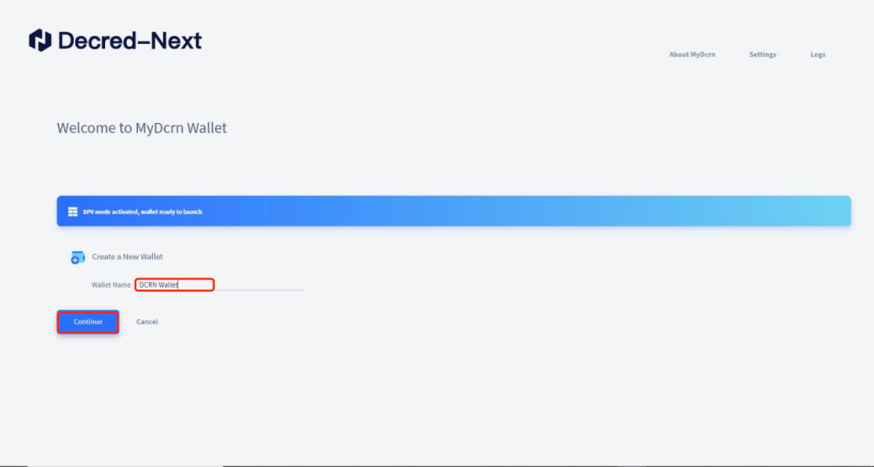

Step 5: Save Seed Words, which is the key to retrieve your wallet, and click **Continue**.

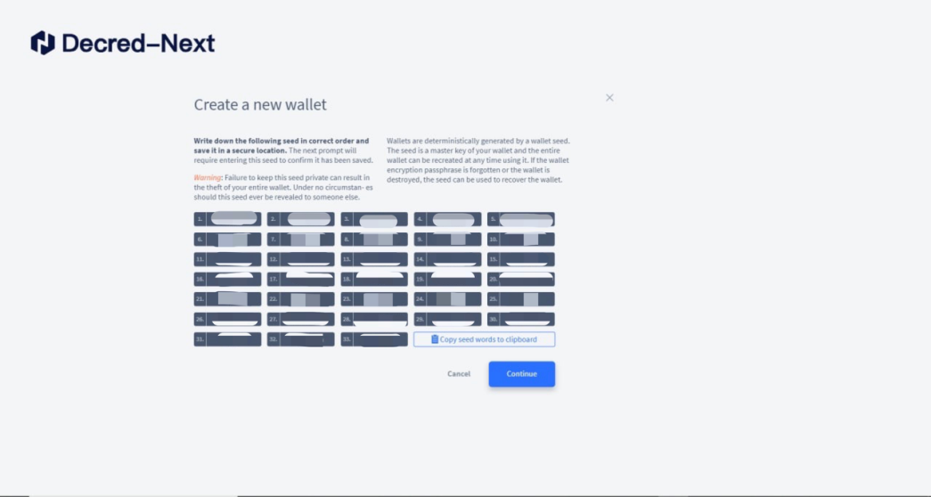

Step 6: Complete the Confrim Seed Key according to the saved Seed Words, enter the Private Passphrase and click **Create Wallet**.

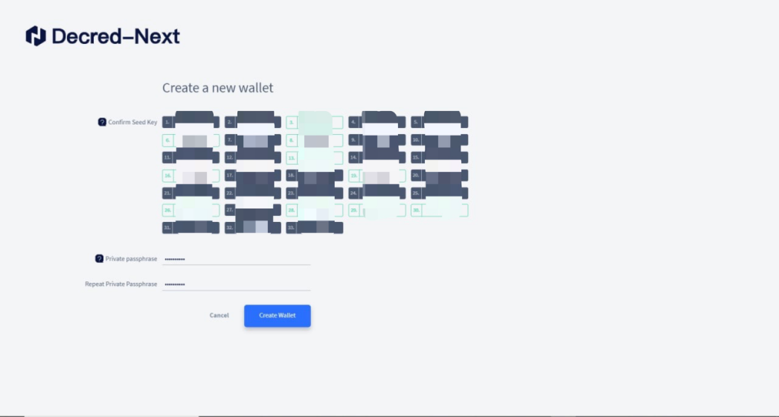

Step 7: The DCRN wallet is created, click **Generate a DCRN Address for receiving funds** to get the DCRN wallet address.

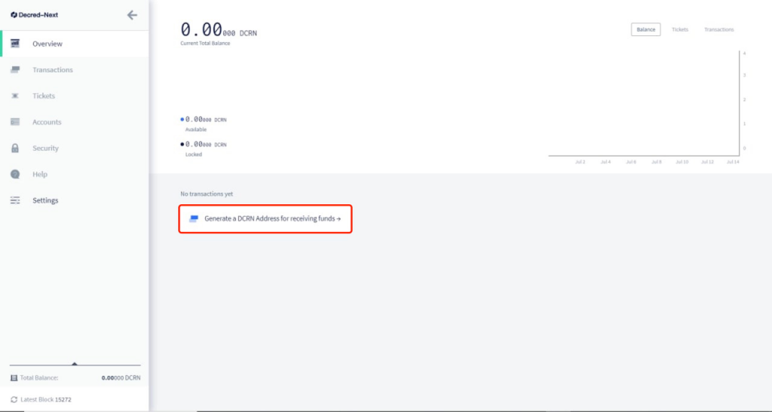

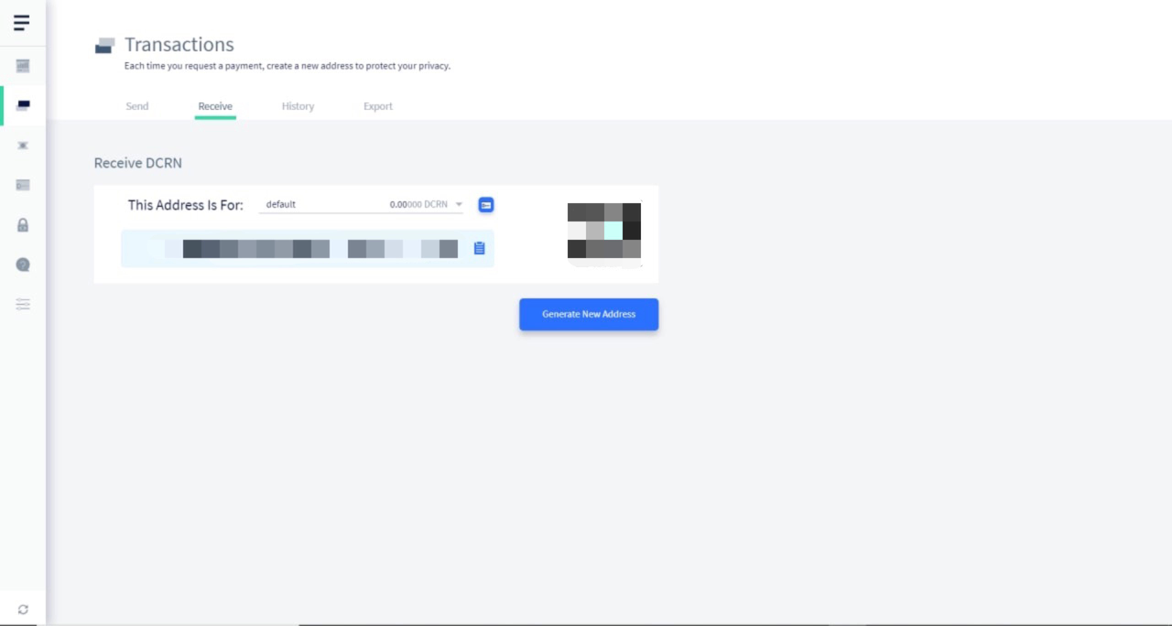

Step 8: On the Tickets page, click the link **https://stakedcrn.net** to complete the registration to get the API Key, VSP select **https://stakedcrn.net** and paste the obtained API Key, click **Continue** to complete Add a VSP.

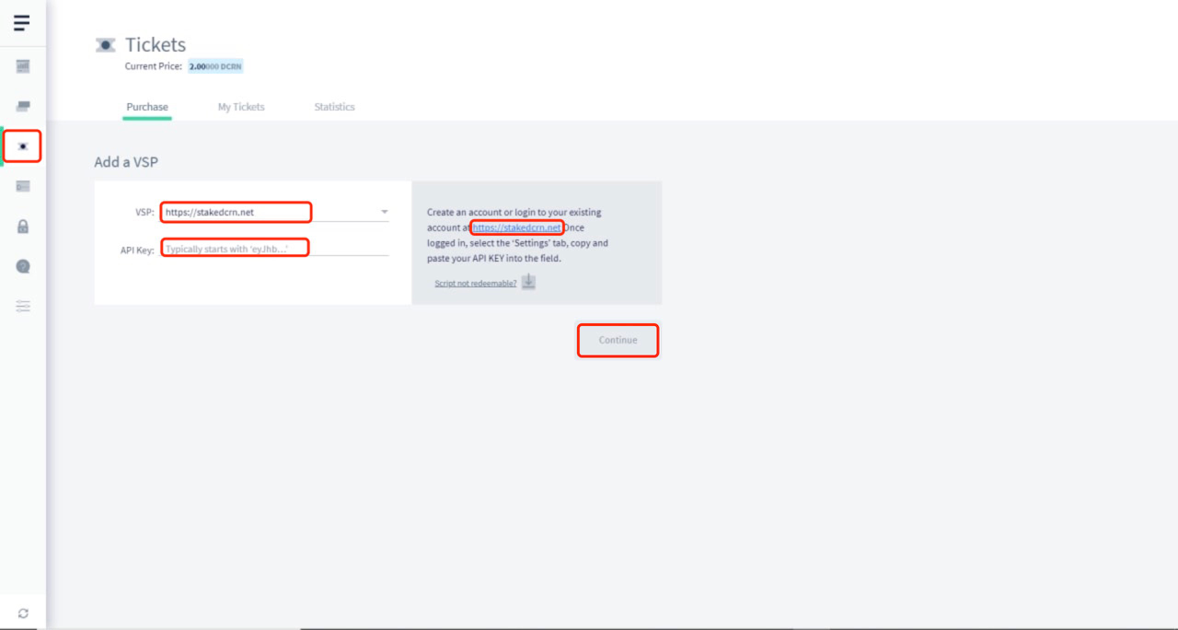

Step 9: You can purchase Tickets based on the DCRN balance to complete the Stake

